BASIS FOR COMPARISON | PARAMETRIC TEST | NONPARAMETRIC TEST
Meaning | A statistical test, in which specific assumptions are made about the population parameter is known as parametric test. | A statistical test used in the case of non-metric independent variables, is called non-parametric test.
Basis of test statistic | Distribution | Arbitrary
Measurement level | Interval or ratio | Nominal or ordinal
Measure of central tendency | Mean | Median
Information about population | Completely known | Unavailable
Applicability | Variables | Variables and Attributes
Correlation test | Pearson | Spearman

DETERMINISTIC ALGORITHM

In computer science, a deterministic algorithm is an algorithm which, given a particular input, will always produce the same output, with the underlying machine always passing through the same sequence of states. Deterministic algorithms are by far the most studied and familiar kind of algorithm, as well as one of the most practical, since they can be run on real machines efficiently.

**********************************************************************************************************************************************************************

Maximum depth refers to the the length of the longest path from a root to a leaf.

*********************************************************************************************************************************************************************

Imagine that you're trying to classify politicians into two groups: those who are honest, and those who are not. I'll give you a list of 100 people, half of which are honest, and you'll give me a list of all the honest ones, but being careful not to accidentally include anyone who is not.

Having high precision means that when you do say that someone is honest, you're usually right about it. This is about how many politicians in your list are actually honest, out of all the ones that you've added to the list.

Having high recall means that you can identify most of the honest politicians out there. This is about how many honest politicians you've added to your list, out of all the ones that exist.

Note that these are not the same. You could add a single honest politician to the list. You would then have very high precision, since the only person that you've listed is actually honest; but you would also have very low recall: there are 50 honest politicians out there but you've only mentioned one.

Ideally, you'd want to list all honest politicians that exist while being careful to not accidentally include some who are not. If you could do that, then you'd have both high precision and high recall.

When measuring how well you're doing, it's often useful to have a single number to describe your performance. We could define that number to be, for instance, the mean of your precision and your recall. This is exactly what the F1-score is.

The only reason why we use the harmonic mean is because we're taking the average of ratios (percentages), and in that case the harmonic mean is more appropriate than the arithmetic mean.

p=tp/tp+fp

r=tp/tp+fn

F1=2pr/p+r=⋯.....=2tp/2tp+fp+fn

**********************************************************************************************************************************************************************

A stemmer for English operating on the stem cat should identify such strings as cats, catlike, and catty. A stemming algorithm might also reduce the words fishing, fished, and fisher to the stem fish. The stem need not be a word, however. In the Porter algorithm, argue, argued, argues, arguing, and argus reduce to the stem argu.

***********************************************************************************************************************************************************************

Natural language processing (nlp) is a research field that presents many challenges such as natural language understanding.

Text may contain stop words like ‘the’, ‘is’, ‘are’. Stop words can be filtered from the text to be processed. There is no universal list of stop words in nlp research, however the nltk module contains a list of stop words.

Object standardization is pre-processing techniques that can be done on abbreviations such as “rt → retweet, dm → direct message”.

***********************************************************************************************************************************************************************

Ridge and Lasso Regression Models

In this post, we’ll explore ridge and lasso regression models. The idea is that by shrinking or regularizing the coefficients, prediction accuracy can be improved, variance can be decreased, and model interpretabily can also be improved.

In ridge regression, we add a penalty by way of a tuning parameter called lambda which is chosen using cross validation. The idea is to make the fit small by making the residual sum or squares small plus adding a shrinkage penalty. The shrinkage penalty is lambda times the sum of squares of the coefficients so coefficients that get too large are penalized. As lambda gets larger, the bias is unchanged but the variance drops. The drawback of ridge is that it doesn’t select variables. It includes all of the variables in the final model

In lasso, the penalty is the sum of the absolute values of the coefficients. Lasso shrinks the coefficient estimates towards zero and it has the effect of setting variables exactly equal to zero when lambda is large enough while ridge does not. Hence, much like the best subset selection method, lasso performs variable selection. The tuning parameter lambda is chosen by cross validation. When lambda is small, the result is essentially the least squares estimates. As lambda increases, shrinkage occurs so that variables that are at zero can be thrown away. So, a major advantage of lasso is that it is a combination of both shrinkage and selection of variables. In cases with very large number of features, lasso allow us to efficiently find the sparse model that involve a small subset of the features.

***********************************************************************************************************************************************************************

After Adding a feature in the feature space,whether the feature is important or unimportant features the R-Squared always increase.

************************************************************************************************************************************************************************

Correlation between features does not change if you add or subtract values to the features.

********************************************************************************************************************************************************************

First off, what is a learning rate?
Learning rate is a hyper-parameter that controls how much we are adjusting the weights of our network with respect the loss gradient. The lower the value, the slower we travel along the downward slope. While this might be a good idea (using a low learning rate) in terms of making sure that we do not miss any local minima, it could also mean that we’ll be taking a long time to converge — especially if we get stuck on a plateau region.
The following formula shows the relationship.
new_weight = existing_weight — learning_rate * gradient

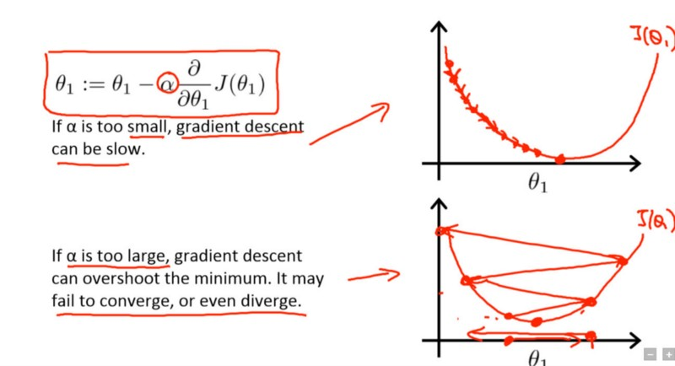

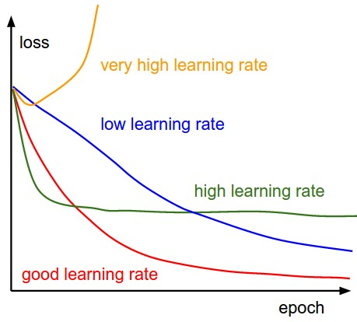

Linear or Identity Activation Function
As you can see the function is a line or linear.Therefore, the output of the functions will not be confined between any range.

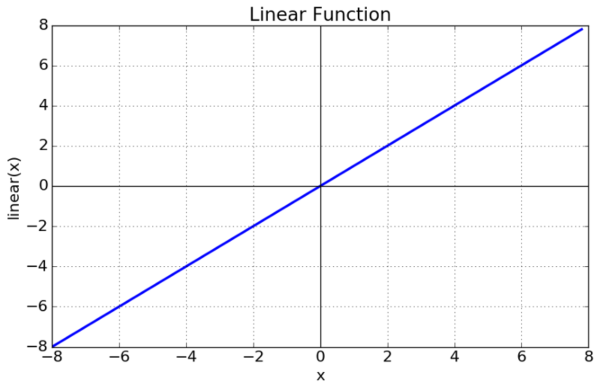

Equation : f(x) = x
Range : (-infinity to infinity)

Non-linear Activation Function
The Nonlinear Activation Functions are the most used activation functions. Nonlinearity helps to makes the graph look something like this

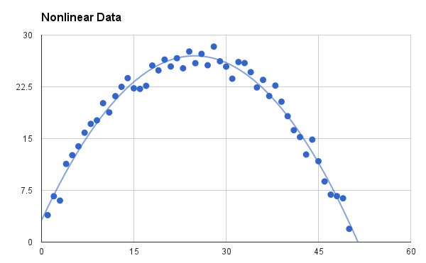

The Nonlinear Activation Functions are mainly divided on the basis of their range or curves-
1. Sigmoid or Logistic Activation Function
The Sigmoid Function curve looks like a S-shape.

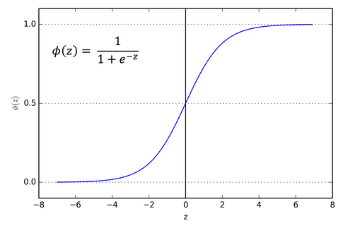

The main reason why we use sigmoid function is because it exists between (0 to 1). Therefore, it is especially used for models where we have to predict the probability as an output.Since probability of anything exists only between the range of 0 and 1, sigmoid is the right choice.
The function is differentiable.That means, we can find the slope of the sigmoid curve at any two points.

2. Tanh or hyperbolic tangent Activation Function
tanh is also like logistic sigmoid but better. The range of the tanh function is from (-1 to 1). tanh is also sigmoidal (s - shaped).
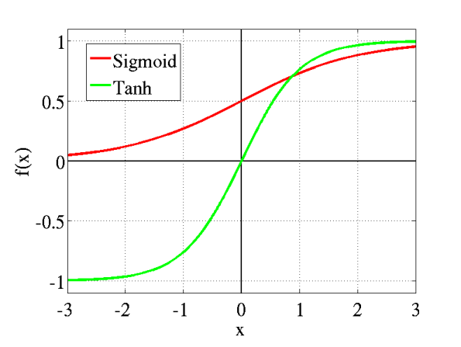
The advantage is that the negative inputs will be mapped strongly negative and the zero inputs will be mapped near zero in the tanh graph.
The tanh function is mainly used classification between two classes.

3. ReLU (Rectified Linear Unit) Activation Function
The ReLU is the most used activation function in the world right now.Since, it is used in almost all the convolutional neural networks or deep learning.
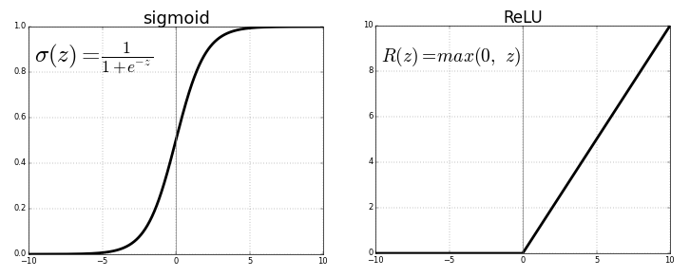
As you can see, the ReLU is half rectified (from bottom). f(z) is zero when z is less than zero and f(z) is equal to z when z is above or equal to zero.
Range: [ 0 to infinity)

Low VarianceHigh VarianceLow Bias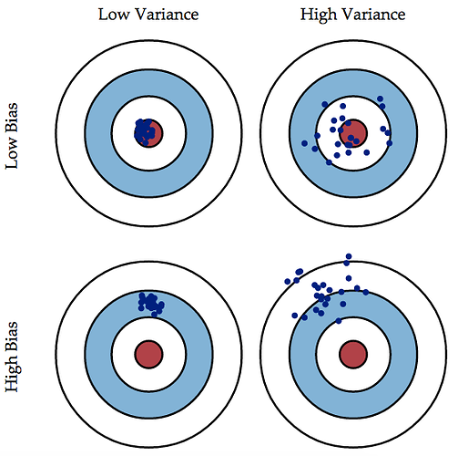

Overfitting occurs when a statistical model or machine learning algorithm captures the noise of the data. Intuitively, overfitting occurs when the model or the algorithm fits the data too well. Specifically, overfitting occurs if the model or algorithm shows low bias but high variance. Overfitting is often a result of an excessively complicated model, and it can be prevented by fitting multiple models and using validation or cross-validation to compare their predictive accuracies on test data.
Underfitting occurs when a statistical model or machine learning algorithm cannot capture the underlying trend of the data. Intuitively, underfitting occurs when the model or the algorithm does not fit the data well enough. Specifically, underfitting occurs if the model or algorithm shows low variance but high bias. Underfitting is often a result of an excessively simple model.
Both overfitting and underfitting lead to poor predictions on new data sets.

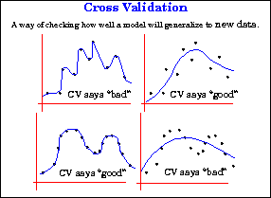

Cross-Validation in Machine Learning
There is always a need to validate the stability of your machine learning model. I mean you just can’t fit the model to your training data and hope it would accurately work for the real data it has never seen before. You need some kind of assurance that your model has got most of the patterns from the data correct, and its not picking up too much on the noise, or in other words its low on bias and variance.

Validation
This process of deciding whether the numerical results quantifying hypothesized relationships between variables, are acceptable as descriptions of the data, is known as validation. Generally, an error estimation for the model is made after training, better known as evaluation of residuals. In this process, a numerical estimate of the difference in predicted and original responses is done, also called the training error. However, this only gives us an idea about how well our model does on data used to train it. Now its possible that the model is underfitting or overfitting the data. So, the problem with this evaluation technique is that it does not give an indication of how well the learner will generalize to an independent/ unseen data set. Getting this idea about our model is known as Cross Validation.

Holdout Method
Now a basic remedy for this involves removing a part of the training data and using it to get predictions from the model trained on rest of the data. The error estimation then tells how our model is doing on unseen data or the validation set. This is a simple kind of cross validation technique, also known as the holdout method. Although this method doesn’t take any overhead to compute and is better than traditional validation, it still suffers from issues of high variance. This is because it is not certain which data points will end up in the validation set and the result might be entirely different for different sets.

K-Fold Cross Validation
As there is never enough data to train your model, removing a part of it for validation poses a problem of underfitting. By reducing the training data, we risk losing important patterns/ trends in data set, which in turn increases error induced by bias. So, what we require is a method that provides ample data for training the model and also leaves ample data for validation. K Fold cross validation does exactly that.
In K Fold cross validation, the data is divided into k subsets. Now the holdout method is repeated k times, such that each time, one of the k subsets is used as the test set/ validation set and the other k-1 subsets are put together to form a training set. The error estimation is averaged over all k trials to get total effectiveness of our model. As can be seen, every data point gets to be in a validation set exactly once, and gets to be in a training set k-1times. This significantly reduces bias as we are using most of the data for fitting, and also significantly reduces variance as most of the data is also being used in validation set. Interchanging the training and test sets also adds to the effectiveness of this method. As a general rule and empirical evidence, K = 5 or 10 is generally preferred, but nothing’s fixed and it can take any value.

Stratified K-Fold Cross Validation
In some cases, there may be a large imbalance in the response variables. For example, in dataset concerning price of houses, there might be large number of houses having high price. Or in case of classification, there might be several times more negative samples than positive samples. For such problems, a slight variation in the K Fold cross validation technique is made, such that each fold contains approximately the same percentage of samples of each target class as the complete set, or in case of prediction problems, the mean response value is approximately equal in all the folds. This variation is also known as Stratified K Fold.
Above explained validation techniques are also referred to as Non-exhaustive cross validation methods.

Leave-P-Out Cross Validation
This approach leaves p data points out of training data, i.e. if there are n data points in the original sample then, n-p samples are used to train the model and p points are used as the validation set. This is repeated for all combinations in which original sample can be separated this way, and then the error is averaged for all trials, to give overall effectiveness.
This method is exhaustive in the sense that it needs to train and validate the model for all possible combinations, and for moderately large p, it can become computationally infeasible.
A particular case of this method is when p = 1. This is known as Leave one out cross validation. This method is generally preferred over the previous one because it does not suffer from the intensive computation, as number of possible combinations is equal to number of data points in original sample or n.
Cross Validation is a very useful technique for assessing the effectiveness of your model, particularly in cases where you need to mitigate overfitting. It is also of use in determining the hyper parameters of your model, in the sense that which parameters will result in lowest test error.

Principal Component Analysis, or PCA, is a well-known and widely used technique applicable to a wide variety of applications such as dimensionality reduction, data compression, feature extraction, and visualization. The basic idea is to project a dataset from many correlated coordinates onto fewer uncorrelated coordinates called principal components while still retaining most of the variability present in the data.
Singular Value Decomposition, or SVD, is a computational method often employed to calculate principal components for a dataset. Using SVD to perform PCA is efficient and numerically robust. Moreover, the intimate relationship between them can guide our intuition about what PCA actually does and help us gain additional insights into this technique.

***************************************************************************8

Leave-one-out cross validation has the maximum accuracy.(specially in case of k-NN).

And therefore 1-NN will have least accuracy.

Bagging (Bootstrap Aggregation) is used when our goal is to reduce the variance of a decision tree. Here idea is to create several subsets of data from training sample chosen randomly with replacement. Now, each collection of subset data is used to train their decision trees. As a result, we end up with an ensemble of different models. Average of all the predictions from different trees are used which is more robust than a single decision tree.

Log Loss
Logarithmic loss (related to cross-entropy) measures the performance of a classification model where the prediction input is a probability value between 0 and 1. The goal of our machine learning models is to minimize this value. A perfect model would have a log loss of 0. Log loss increases as the predicted probability diverges from the actual label. So predicting a probability of .012 when the actual observation label is 1 would be bad and result in a high log loss. There is a more detailed explanation of the justifications and math behind log loss here.

